# MTD Sim Parameters

## Network Parameters

|  |  |
| --- | --- |
| **Parameter** | **Description** |
| Total Nodes | Number of nodes that will be generated for the network |
| Total Endpoints | The number of nodes that are generated as exposed (i.e. attacker will always find these nodes without compromising any nodes and the connection point will remain static [IP and ports remain static]) |
| Total Subnets | Number of subnets found in network (randomly spread between layers) |
| Total Layers | Number of layers found in network |
| Target Layer | Layer number the target node will be on (if targeted attack) |

## Network Example

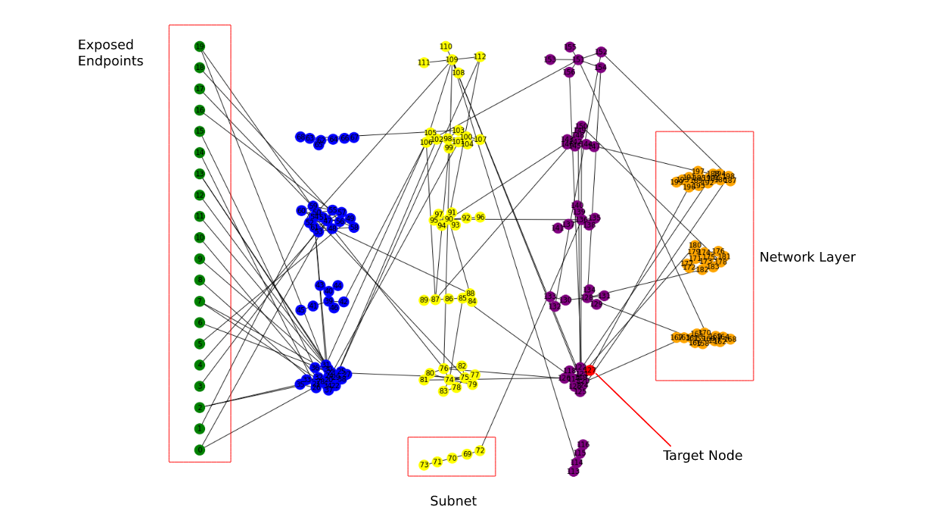

## Host Parameters

NOTE: Every network node has ONE host instance

|  |  |
| --- | --- |
| **Parameter** | **Description** |
| Operating System | One of the operating systems (selected from constants.py) |
| OS Version | Version number of the operating system (selected from constants.py) |
|  |  |
|  |  |
|  |  |
|  |  |